Assignment 7 Austin Frownfelter

# Problem 1

## Part A

I was able to achieve a test error of 0.1965 with “show”=20 and “max_fail”=20 on 2000 maximum epochs (though it only went 23 epochs before failing validation). Those weights are below. I also included the ROC curve for this result. The area under this curve is pretty good. The Test ROC was interesting, with a very steep slope initially, then very shallow.

|  |  |  |  |  |  |  |  |  |  |
| --- | --- | --- | --- | --- | --- | --- | --- | --- | --- |
| -1.1338 | -2.4487 | 0.2098 | 0.8407 | 0.1185 | -1.9670 | -1.8999 | -1.5447 | -1.1338 | -2.4487 |
| 1.1153 | -0.1048 | -1.0840 | -0.8189 | 0.3486 | 0.7871 | 0.2821 | -0.4831 | 1.1153 | -0.1048 |
| 0.7586 | 0.0031 | -0.6792 | 0.4744 | 0.2797 | 1.0381 | 1.0046 | -0.1736 | 0.7586 | 0.0031 |
| 0.5665 | -0.2325 | -0.4173 | -1.2674 | 0.3744 | 0.4575 | 0.0792 | 1.5707 | 0.5665 | -0.2325 |
| 1.1848 | 1.2176 | 0.0862 | -0.3354 | 0.1107 | 1.0972 | -0.6941 | 1.7341 | 1.1848 | 1.2176 |
| -2.0209 | -2.2427 | 0.6822 | -1.0083 | -0.5995 | -0.3791 | -0.8395 | -0.4449 | -2.0209 | -2.2427 |
| -0.0705 | -1.1472 | 0.2463 | 0.1066 | 1.0130 | -0.1444 | 1.3642 | 0.9489 | -0.0705 | -1.1472 |
| 1.4244 | 0.0739 | -0.0876 | 1.4391 | -1.2256 | 1.3643 | -1.1239 | 0.5455 | 1.4244 | 0.0739 |

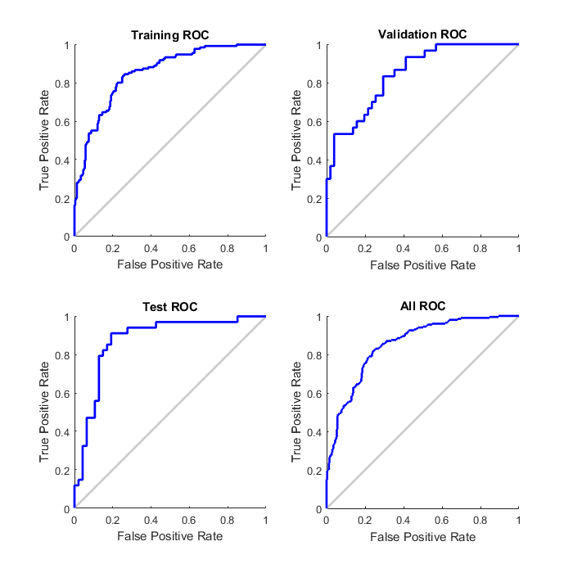

## Part B

The logistic regression model from part a resulted in (in my best case) test and train errors of 0.1965 and 0.2319, respectively. The best I achieved was 0.2140 and 0.2375. In this case, the logistic model worked better, probably because 2 non-linear units is not enough to represent this data set.

## Part C

|  |  |  |  |  |  |  |  |  |
| --- | --- | --- | --- | --- | --- | --- | --- | --- |
| type | 2 | 2 | 3 | 3 | 5 | 5 | 10 | 10 |
|  | Test | Train | Test | Train | Test | Train | Test | Train |
| cgf | 0.2140 | 0.2375 | 0.2140 | 0.2356 | 0.2009 | 0.2263 | 0.214 | 0.2189 |
| lm | 0.1878 | 0.2245 | 0.1965 | 0.2245 | 0.1965 | 0.2226 | 0.1921 | 0.2282 |
| oss | 0.2183 | 0.2338 | 0.2052 | 0.2245 | 0.2183 | 0.2356 | 0.2096 | 0.2245 |
| scg | 0.1965 | 0.2375 | 0.2052 | 0.2319 | 0.2052 | 0.2338 | 0.1921 | 0.2115 |
| bfg | 0.2096 | 0.2245 | 0.2052 | 0.2338 | 0.2052 | 0.2301 | 0.2009 | 0.2245 |

I ran the model with different training functions and took the top 5 performing functions across the 5 networks. They were run as show=20, max_fail=20, epochs=2000. In all cases, the “trainlm” function performed the best, with the remaining positions being filled by different functions depending on the network.

# Problem 2

## Part A

The unrestricted tree is very dense, and may be prone to overfitting. In this case, the unrestricted tree had a test error of 0.2751, while the restricted tree has 0.2576 error. We should try to backprune as much as possible, because of this overfitting problem.

## Part B

|  |  |  |  |  |  |  |  |  |
| --- | --- | --- | --- | --- | --- | --- | --- | --- |
| Min Parents | 20 | 25 | 30 |  | Min Leaf | 5 | 10 | 15 |
|  |  |  |  |  | 10 |  |  | 0.2838 |
| 15 | 0.2314 |  | 0.2227 |  | 15 | 0.2358 | 0.2358 | 0.2227 |
| 20 | 0.2358 | 0.2358 | 0.2358 |  | 20 | 0.2445 | 0.2489 | 0.2533 |
| 25 | 0.2402 | 0.2402 | 0.2707 |  | 25 | 0.2489 | 0.2489 | 0.2445 |

Above I changed the minimum size of the parents, and the minimum size of each leaf (separately) with different max split values.

|  |  |  |  |
| --- | --- | --- | --- |
|  | Prune 1 | Prune 1 | Prune 2 |
|  | Parent 20 | Parent 20 | Parent 20 |
|  | Leaf 10 | Leaf 15 | Leaf 10 |
| 15 | 0.2314 | 0.2314 | 0.2314 |
| 20 | 0.2227 | 0.2227 | 0.2314 |
| 25 | 0.2227 | 0.2140 | 0.2314 |

Above I tried different pruning levels with different max number of split values.

The best result I obtained was an error of 0.2009 by using max splits=35, leaf=7, parent=20, pruning level 1.

# Problem 3

## Part A

|  |  |  |  |
| --- | --- | --- | --- |
| 1 | 3 | 5 | 7 |
| .2969 | .2664 | .2227 | .2489 |

The best I obtained was that 0.2227 value with k=5. Any other values were somewhere above 0.24.

## Part B

Normalizing the data yielded significantly worse results. I used the normalizing function

$norm\left(x\right)=\frac{x-mu}{sigma}$. The error became 0.5599. This may be because each attribute was normalized relative to only that attribute’s values, rather than the whole dataset, changing the relationships between attributes.